Tài liệu Tham khảo :

Trang HOME : <https://www.youtube.com/watch?v=iuau3z8B0h4&list=WL&index=25&ab_channel=DevDomain>

Trang Product:

<https://www.youtube.com/watch?v=Gnh-9IH6BEc&list=WL&index=26&ab_channel=CarpoolVenom>

Trang New Colection: 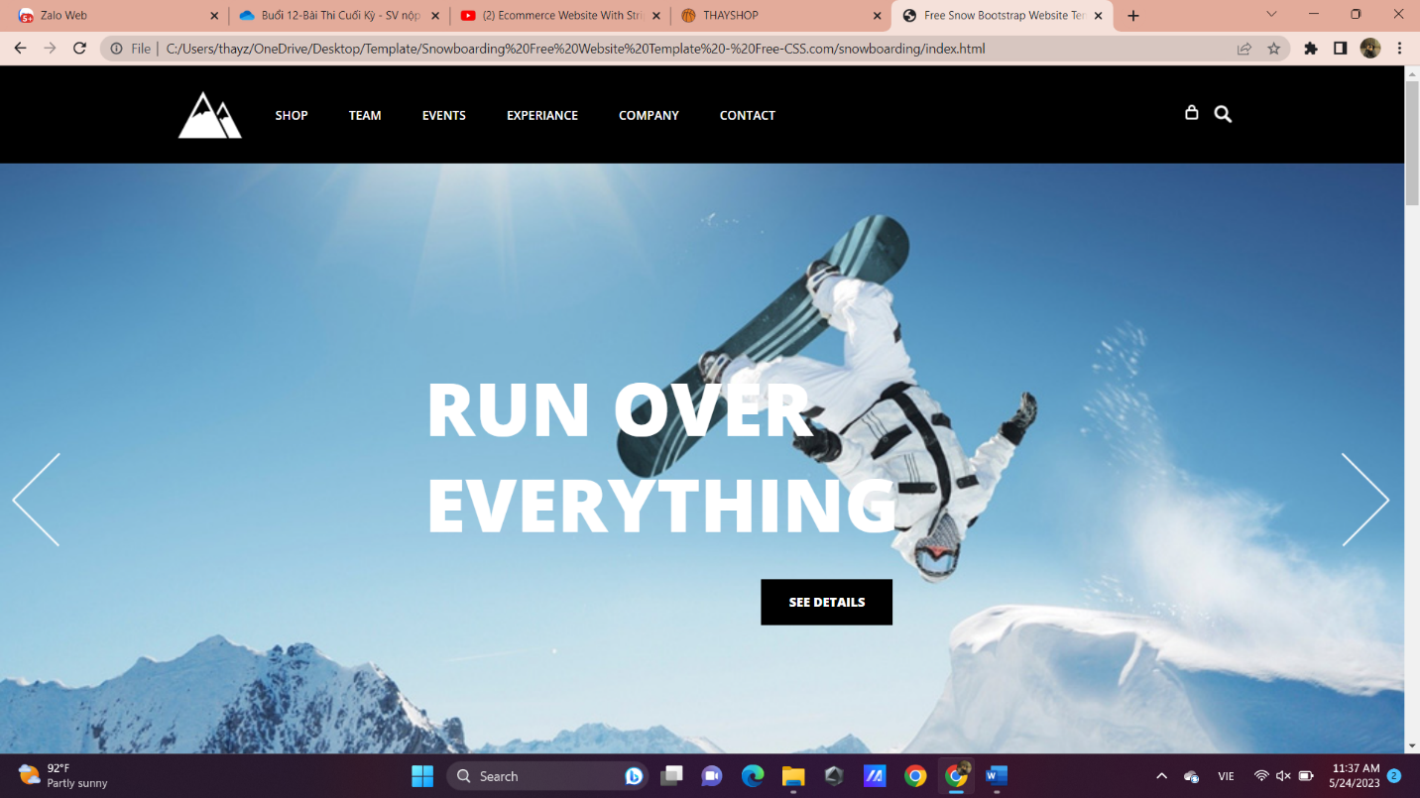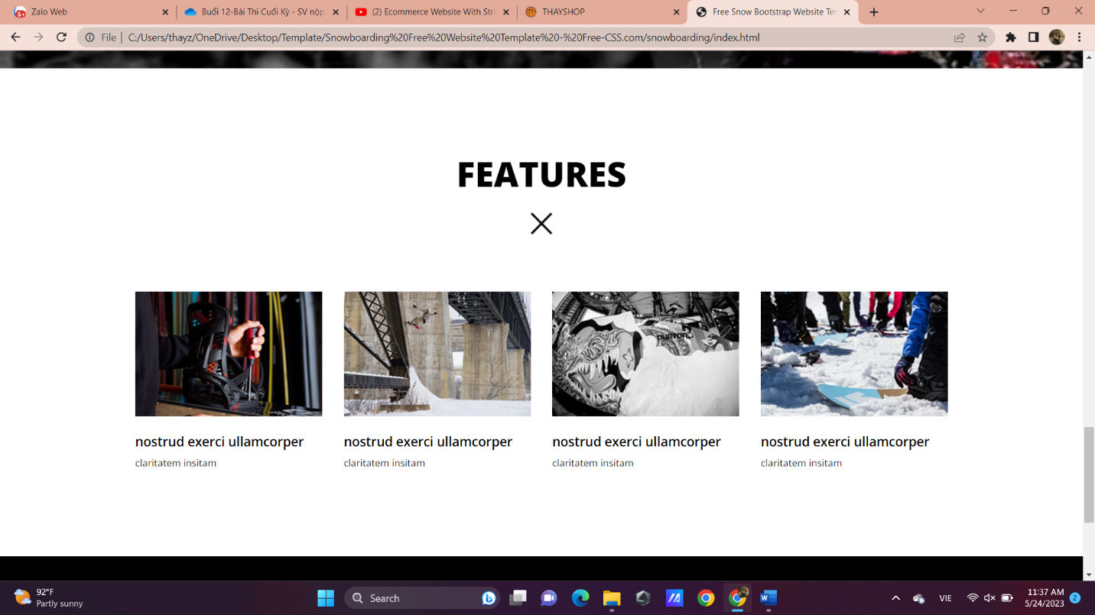

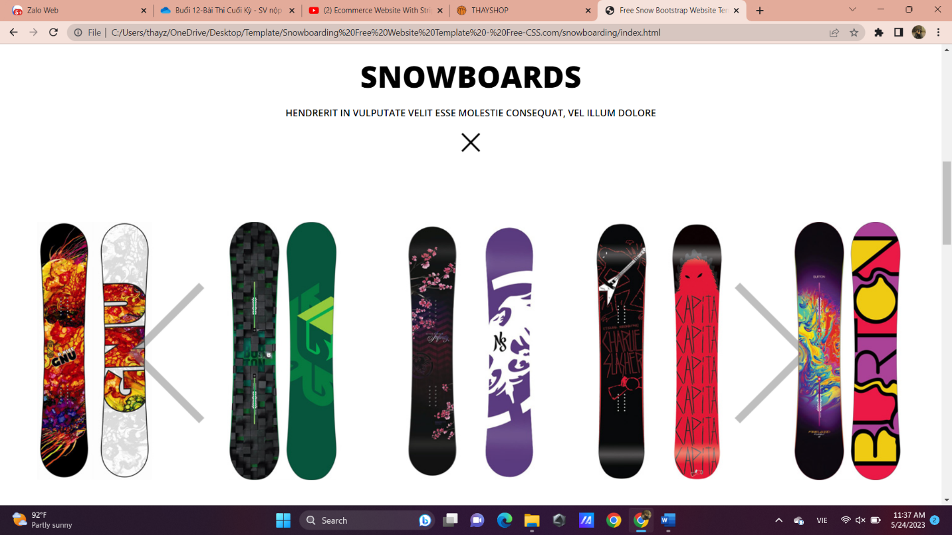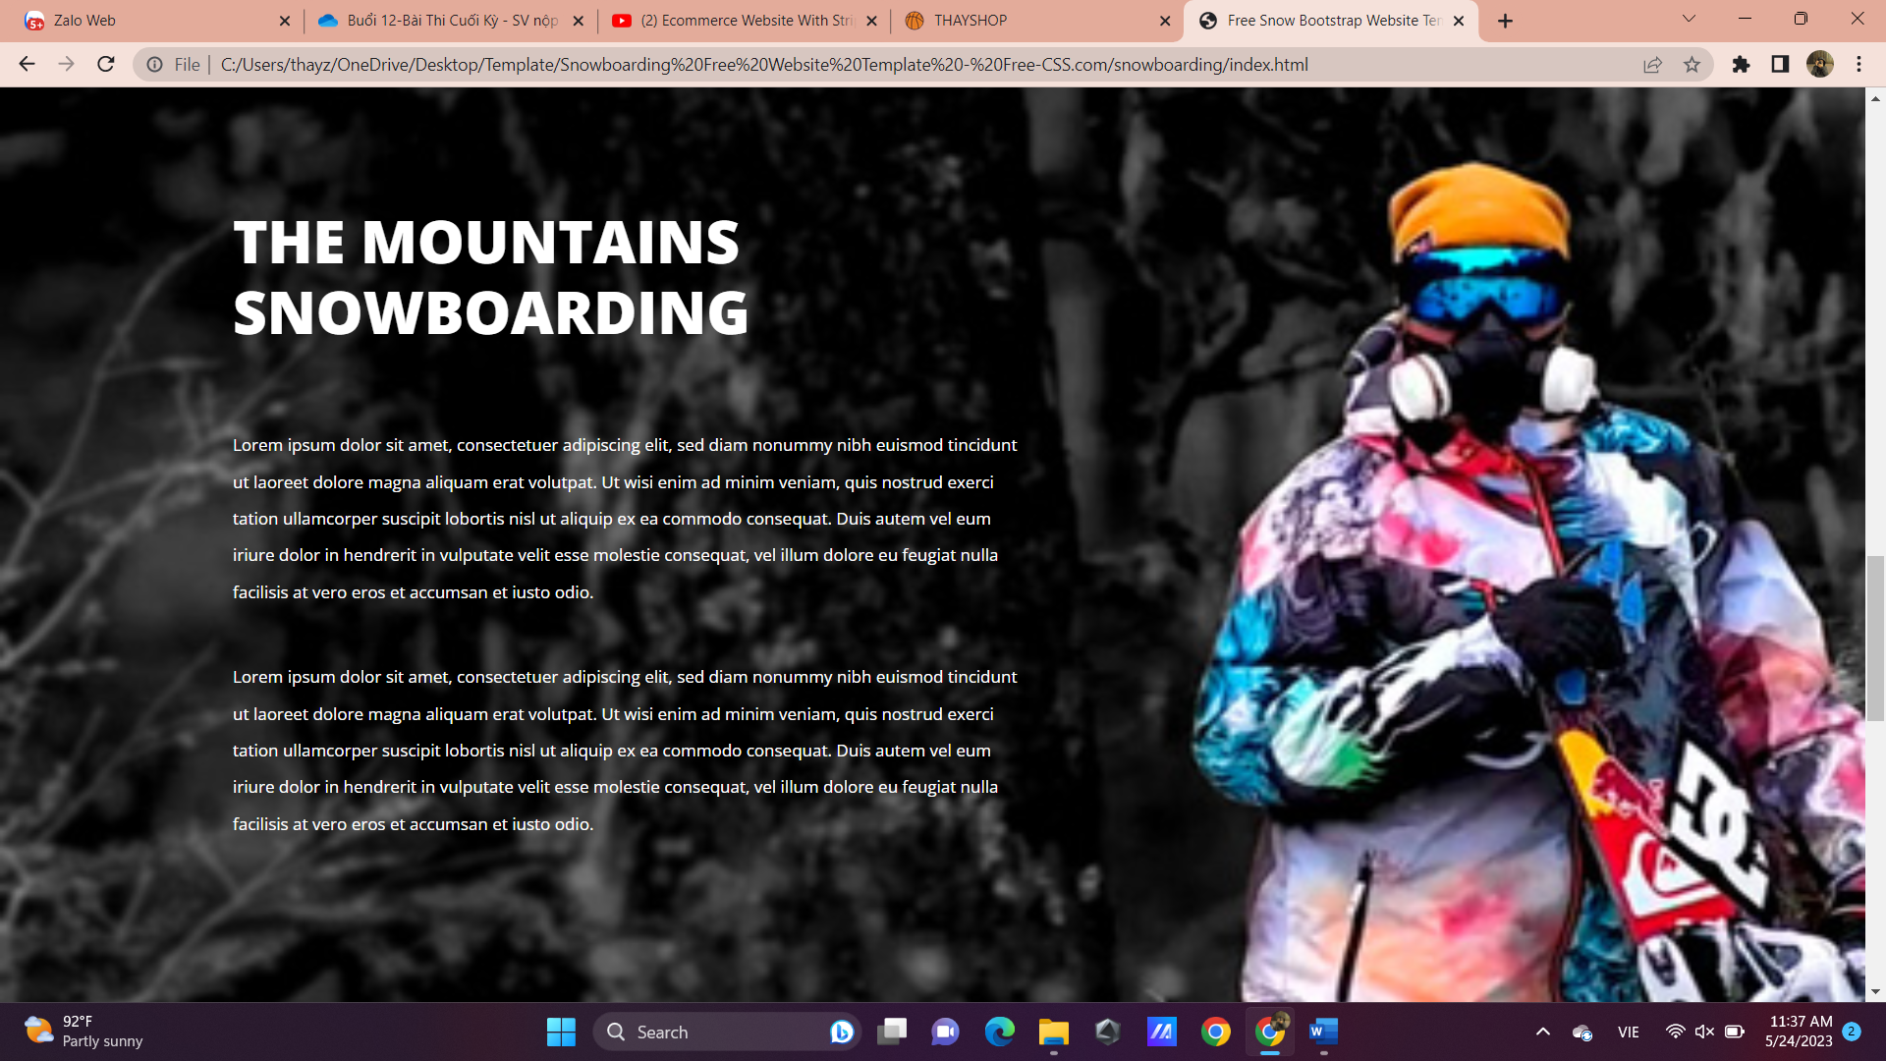

Login Form: https://freefrontend.com/css-login-forms/